|  |  |  |  |  |  |
| --- | --- | --- | --- | --- | --- |
|  |  | | | | |
|  | |  | | | |
| Project: | | ServeMe System (SMS)  CSE 5325 – Spring 2021  Project Management | | | |
| Module: | | COCOMO | | | |
| Deliverable: | | COCOMO Estimate Report | | | |
| Version: | | | [1.0] | Date: | [04/13/2021] |

Prepared by: Siddhesh Jadhav, 1001876969

TABLE OF CONTENTS

1. Introduction 2

2. Estimating Factors 3

2.1 Source of Lines of Code 3

2.2 Scale Drivers 3

2.3 Cost Drivers 3

3 Project Final Timeline and Cost Structure 4

4. Conclusion and Recommendations 5

Appendices 6

# 1. Introduction

This document presents cost, effort & duration estimation for ServeMe System (SMS) using COCOMO II model. One of the most difficult phases in software development is the planning process and the ability to provide accurate cost estimations for a project. The COCOMO II allows us to estimate the cost, effort, and schedule when planning new software development.

ServeMe System is a platform that helps customers connect with service providers required for their home or small business. The client has employed our team to develop this product. The desired outcome of the project is the implementation of the web and mobile application for the client. The project has tight schedules and the duration of the project is of three months. The estimated client budget for the project is $250,000. Previously, based on the delivery date of the project and the cost of the resources (both human & non-human resources), the project plan was created to meet the objectives of the project. The estimated cost to complete the project in three months was $110,480.

At this stage, we used Costar - a tool for the implementation of the COCOMO model, to estimate the effort, duration, and cost required to complete the software project. The calculated effort for this project is estimated to be 5.8 Person-months and the duration in months is 4.9. The human resources cost is $104,600. The company’s expense will rise to $1,48,600 after including the cost of the non-human resources. With this estimated cost, the company will make around 68.24 percent of profit and 40.56 percent of profit margin.

The COCOMO II model suggests that the project will not be completed in 3 months. However, the project is very profitable, and the company should continue with the project since the product has huge potential in the market. The company can add a few more experienced personnel to the project for completing it within a given deadline.

# 2. Estimating Factors

## 2.1 Source of Lines of Code

The following is the number of lines of code delivered as part of this project, A justification for the total amount of LOC is provided.

|  |  |
| --- | --- |
| **SLOC | Source Lines of Code** | Value Chosen: 5000 |
| Justification: Source lines of code will be beyond 5K. However, with the help of code optimization, we can bring it down to 5k. Also, the development team will be using react-native. Thus, there will be a single code base for Android and IOS applications. | |

## 2.2 Scale Drivers

The following is the list of scale drivers, the values applicable to this project and a justification for each value chosen:

|  |  |
| --- | --- |
| **PREC | Precendentedness** | Value Chosen: High |
| Justification: The organization seems to understand the project’s goals and has considerable experience in working related systems. | |
| **FLEX | Development Flexibility** | Value Chosen: Low |
| Justification: The Development flexibility is low because the minimum required functionalities provided by the client are not going to change. Also, the software needs to largely conform to pre-established requirements from client and external interface specifications. | |
| **RESL | Architecture / Risk Resolution** | Value Chosen: High |
| Justification: All critical risk items, schedule, budget, and internal milestones are identified. We assumed and checked that attention placed on architecture and risk identification and mitigation is consistent with a fairly mature process. The degree of design thoroughness and risk elimination is high. | |
| **TEAM | Team Cohesion** | Value Chosen: Very High |
| Justification: All involved stakeholders share a common vision of the product to be developed as well as a common communication and cooperation culture. There exists a well-established trust relationship among all stakeholders. Also, the team will be working together closely. It isn’t distributed and seems to work well together. | |
| **PMAT | Process Maturity** | Value Chosen: High |
| Justification: Organization has a maturity corresponding to a CMM level of 3 | |

## 2.3 Cost Drivers

The following is the list of cost drivers, the values applicable to this project and a justification for each value chosen:

**Personnel Cost-Driver Ratings: -**

|  |  |
| --- | --- |
| **ACAP | Analyst Capability** | Value Chosen: High |
| Justification: We assume that the analysts devoted to this project are going to be some of the bests in the business. The mix of personnel will be such that we can assume “high” as the norm for the project. We also assume that the analysts in the team have top design and programming ability, work efficiently and thoroughly, and can communicate and cooperate well with all team members. | |
| **APEX | Applications Experience** | Value Chosen: High |
| Justification: The team working on the project will have all the required skills and a good amount of experience to be able to deliver a fully functional product. Moreover, the project managers & senior software developers in the company have more than 5 years of experience in the management and implementation of the software product. | |
| **PCAP | Programmer Capability** | Value Chosen: Very High |
| Justification: Programmers in the company possess great analytical, programming & technical skills. Programmers are capable, efficient, and thorough. They can communicate and cooperate very well. | |
| **PCON | Personnel Continuity** | Value Chosen: Very High |
| Justification: Company has a very high rate of continuity among the personnel and no member of the team is going to quit. Also, we assume that dedicated personnel (Single development project team) are arranged for this project and the % of personnel who leave this project and are replaced by new personnel is very low, hence we have a very high Personnel continuity. | |
| **PLEX | Platform Experience** | Value Chosen: High |
| Justification: The application will be developed on the MERN stack. The developers in the company have good experience working on this platform. The company has high-level developers who are experts with specialized roles both in frontend and backend development. And they understand the platform very well. | |
| **LTEX | Language and Tool Experience** | Value Chosen: High |
| Justification: The development team plans to develop this application with HTML, CSS, JavaScript, React JS, Express JS, Node JS and use Mongo DB to query information from the database. The tools for programming are Atom, Robo 3T, Postman. The language and tool experience is high because team members have at least three-year experience with these languages and tools. | |

**Product Cost-Driver Ratings: -**

|  |  |
| --- | --- |
| **RELY | Required Software Reliability** | Value Chosen: High |
| Justification: As the client does not have any shops/centers for its product; its primary channel is web and mobile applications for providing services to its customers. If the software does not perform its function, it would result in a comparative high financial loss for the client. | |
| **DATA | Database Size** | Value Chosen: Low |
| Justification: The amount of test data needed is small compared to the amount of SLOC of the application. | |
| **CPLX | Software Product Complexity** | Value Chosen: Nominal |
| Justification: The application will have simple callbacks or message passing, including middleware supported distributed processing. The computations are standard mathematical formulas and the GUI is fairly simple. | |
| **RUSE | Required Reusability** | Value Chosen: Low |
| Justification: This project is intended to be not reused for future projects. Hence the value of the reusability factor should be low. It is just a one-time project. | |
| **DOCU | Documentation Match to Life-Cycle Needs** | Value Chosen: Nominal |
| Justification: We will not be attempting to save costs or time via low documentation levels. For maintenance purposes, the documentation should be right-sized for life-cycle needs. Therefore, the value for this factor is nominal. | |

**Platform Cost-Driver Ratings: -**

|  |  |
| --- | --- |
| **TIME | Execution Time Constraint** | Value Chosen: Nominal |
| Justification: The application is intended to use ≤ 50% of the available execution time. Considering the application will be deployed on the cloud, it will scale automatically based on the load. | |
| **STOR | Main Storage Constraint** | Value Chosen: Nominal |
| Justification: Data storage constraints are not big issue for this application. It will be deployed on the cloud since no compromises can be made at the expense of the database size. | |
| **PVOL | Platform Volatility** | Value Chosen: Low |
| Justification: Major changes on the platform are expected approximately every 12 months. Considering the application will be deployed on the cloud; a cloud-agnostic system architecture will be adopted. Hence, we assume the volatility of the platform will be low. | |

**Project Cost-Driver Ratings: -**

|  |  |
| --- | --- |
| **TOOL | Use of Software Tools** | Value Chosen: High |
| Justification: We assume that we will have a strong, mature set of tools that are moderately integrated. | |
| **SCED | Required Development Schedule** | Value Chosen: Very low |
| Justification: The constrained schedule is 75% of the nominal schedule (i.e., the estimate when SCED is set to nominal). | |
| **SITE | Multisite Development** | Value Chosen: Very High |
| Justification: All team members will be working together closely at the same workplace. Additionally, we will be using wideband electronic communication and occasional video conference. | |

# 3 Project Final Timeline and Cost Structure

This section provides a summary of previously estimated cost and schedule, along with the new schedule & COCOMO estimated costs.

The estimated client’s budget is **$250,000**. The project duration is three months.

**3.1 Previous estimated cost and schedule: -**

The below table shows previously estimated cost, work, and duration by the Microsoft Project Plan: -

|  |  |
| --- | --- |
|  |  |
| **Parameter** | **Value** |
| Previous Total Cost | $110,480 |
| Human Resources Cost | $66,480 |
| Non-Human Resources Cost | $44,000 |
| Work | 1,668 Hrs |
| Duration | 65 days (Weekends excluded) |

The below picture shows previous cost distribution from the Microsoft project plan: -

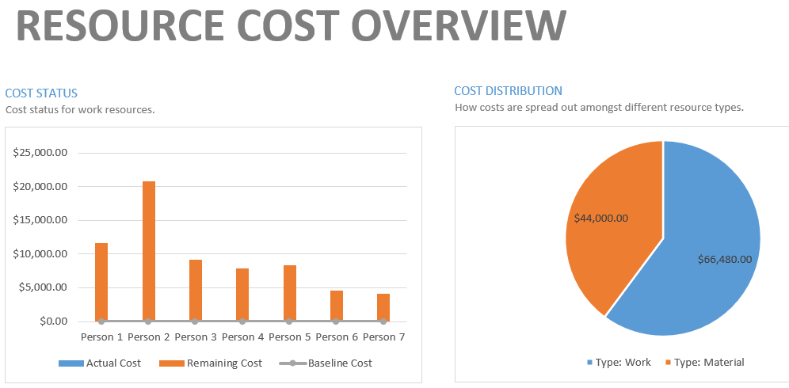

**3.2 COCOMO estimated cost, effort & duration: -**

The below table shows COCOMO estimated costs (Human Resources), effort, new duration, and Non-Human Resources cost: -

|  |  |
| --- | --- |
| **Parameter** | **Value** |
| Cost (K$) | $ 104.6K |
| Non-Human Resources Cost | $44,000 |
| Effort in Person-Months | 5.8 |
| Duration in Months | 4.9 |

Total equivalent size: 5000

The new estimated total cost would be around **$1,48,600.**

Thus, the company can expect: -

|  |  |
| --- | --- |
| **Parameter** | **Value** |
| Net Profit Margin: | 40.56% |
| Net Profit: | $101,400.00 |
| Profit Percentage: | 68.24% |

# 4. Conclusion and Recommendations

To conclude, In the previous cost and schedule estimates, we had considered only human & non-human resources cost and created the project timeline based on the delivery date provided by the client.

The new estimates are different from the previous one because COCOMO II is based on several assumptions that have to be considered to predict effort straightforwardly. Key parameters are the project's size in Source Lines of Code, five scale factors, and 17 cost drivers that affect the effort required to complete a project, and address Personnel, Project, Platform, and Product attributes.

The newly calculated effort and duration suggest that the project will not be completed in three months. However, with the new estimated cost, the project is still very profitable.

Recommendations:

The company is capable to complete this project from a technical perspective. The project delivery date needs to be negotiated. The company needs to present the newly estimated COCOMO II cost and schedule to the client and request them to reconsider the delivery dates. If the client disagrees with the new estimated cost and schedule, the company should continue with the project since it will open new opportunities in the market and gain new customers. Also, to avoid overloading resources with the extra work, the company can add 2-3 extra resources to ensure the delivery of the project within the deadline.

# Appendices

COCOMO reports: -

1.

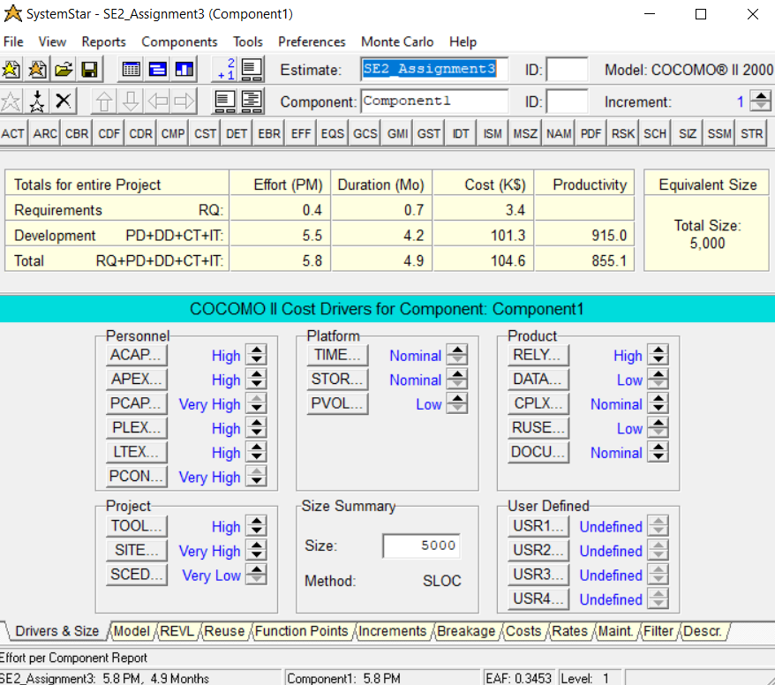

2.

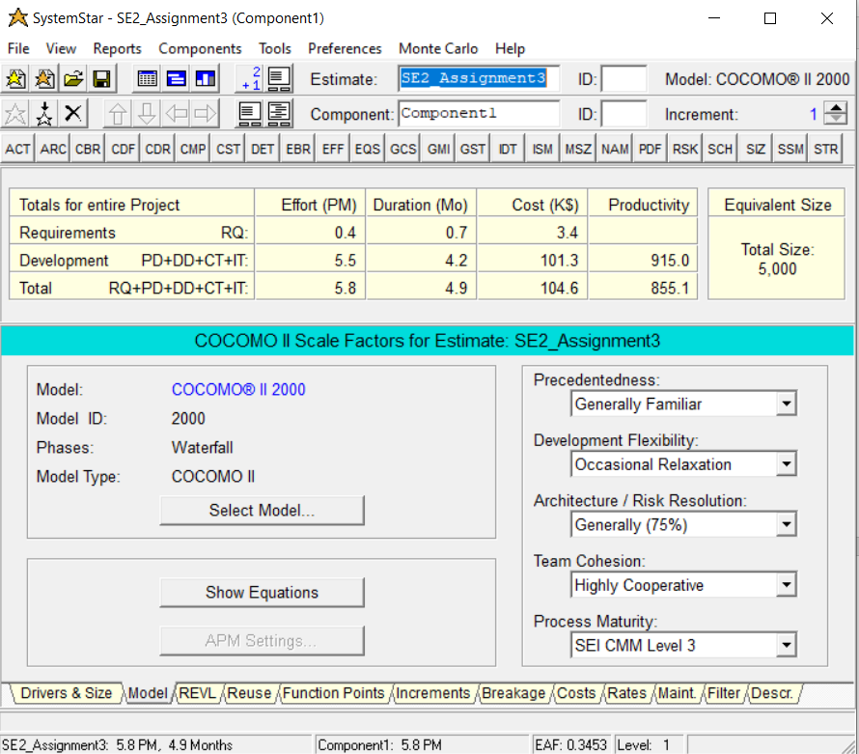

3.

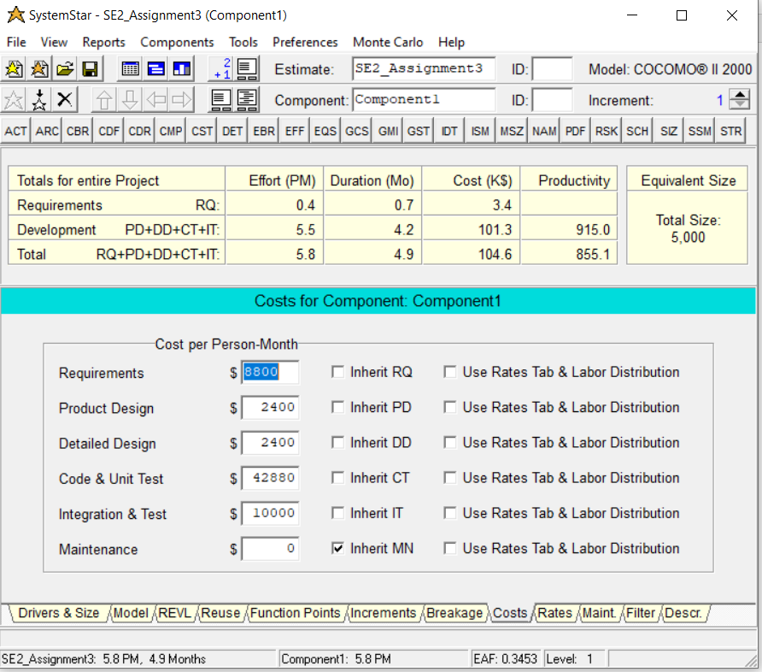

Web References: -

<https://www.codeproject.com/Articles/9266/Software-Project-Cost-Estimates-Using-COCOMO-II-Mo>

<https://perso.univ-st-etienne.fr/jacquene/gl/articles/COCOMO_CaseStudy.pdf>

<https://www.rose-hulman.edu/class/csse/csse372/201410/SlidePDFs/session12.pdf>

<https://myclass.dau.edu/bbcswebdav/institution/Courses/Deployed/ISA/ISA201/Archives/Student%20materials%20prior%20to%20June%202017/03%20-%20Cost%20Estimating/Exercise/3-Lsn3%20Mid%20Exercise/COCOMO%20Cost%20Estimation%20Workbook.pdf>

<https://www.pearsonhighered.com/assets/samplechapter/0/1/3/0/0130266922.pdf>

<https://citeseerx.ist.psu.edu/viewdoc/download?doi=10.1.1.25.7509&rep=rep1&type=pdf#:~:text=Compared%20to%20COCOMO%2081%2C%20COCOMO,%2C%20and%20multi%2Dsite%20development>.

<https://slideplayer.com/slide/14136525/>

<http://ranger.uta.edu/~khalili/Overview%20of%20COCOMO.htm>

<https://courses.cs.ut.ee/MTAT.03.244/2016_fall/uploads/Main/Cocomo2exercise-solution-v02.pdf>

<https://courses.cs.ut.ee/2012/pm/uploads/Main/Tb15.pdf>

<https://courses.cs.ut.ee/MTAT.03.244/2014_fall/uploads/Main/FPASampleReport2014.pdf>

<https://courses.cs.ut.ee/MTAT.03.244/2015_fall/uploads/Main/FPASampleReport2012b.pdf>

<https://courses.cs.ut.ee/MTAT.03.244/2013_fall/uploads/Main/FPASampleReport2012.pdf>

<https://courses.cs.ut.ee/MTAT.03.244/2012_fall/uploads/Main/FPASampleReport2011.pdf>

<https://courses.cs.ut.ee/MTAT.03.244/2014_fall/uploads/Main/FPASampleReport2013.pdf>